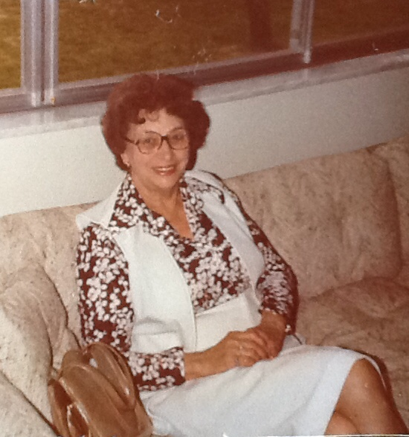

Mary Helen Foster Wolfe – 1957

**Russell Franklin and Mary Helen Foster Wolfe Family**

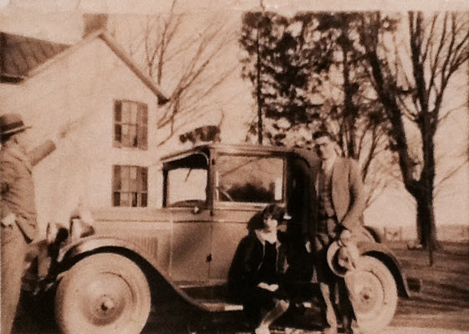

**Russell Franklin and Mary Helen Foster Wolfe (with cat on car) – about 1928** (est.)